12TH ANNUAL LSOMS IMPLANT SEMINAR

Saturday, September 11, 2021 8:00 a.m. – 12:00 p.m.

L’Auberge Casino Hotel 777 L’Auberge Ave., Baton Rouge, LA

EVOLUTION—An Update on Ceramics, CAD/CAM, Bonding & Implants
4 hours continuing education credit

Markus B. Blatz, DMD, PhD

COURSE OBJECTIVES
Upon completion of this presentation, participants should be able to:
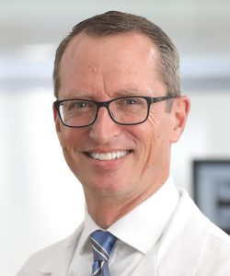

About Dr. Blatz

Professor of Restorative Dentistry, Chairman of the Department of Preventive
and Restorative Sciences, Assistant Dean for digital Innovation and
Professional Development, University of Pennsylvania School of Dental Medicine

Founder of the Penn Dental Medicine CAD/CAM Ceramic Center
Co-Founder of the International Academy for Adhesive Dentistry

Board-Certified Diplomat, German Society for Prosthodontics & Biomaterials

$150 PER DENTAL PROFESSIONAL $100 PER STAFF MEMBER
$25 PER LSU RESIDENT $50 EXTRA FOR WALK-INS

Mail check payable to:

LSOMS
PO Box 1393
Ruidoso, NM 88355 For questions, contact paulettebinion@gmail.com

Name ___________________________________ Phone _______________ Fax _______________

e-mail address _____________________________

Registration opens at 7:30 a.m. Continental breakfast provided.
NO REFUNDS AFTER AUGUST 31, 2021
LOUISIANA SOCIETY OF ORAL & MAXILLOFACIAL SURGEONS

